St Philip’s
Art and Design
Policy

2023-2024

Rationale

At St Philip’s R.C Primary we provide a positive, caring environment, that ensures every child has the opportunity to reach their full potential. We embrace Catholic values and ensure all children are ready for their next steps. We are committed to providing all children with learning opportunities to engage in Art and Design, we believe that every child within our school should have full access to Art and Design as laid down in the National Curriculum regardless of age, gender or ability. We seek to ensure that our teaching reflects the current guidance to schools, which emphasises the particular importance of designing and making.
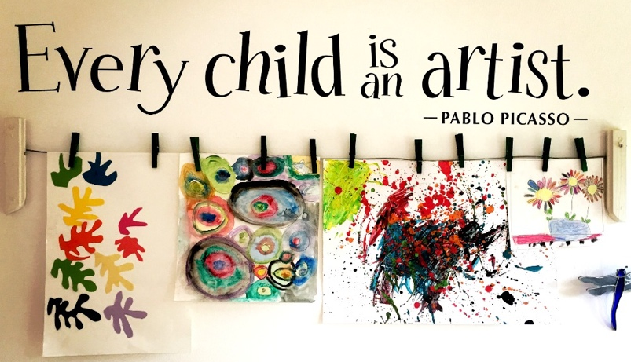

Purpose
The purpose of Art and Design education is to give pupils the skills, concepts and knowledge necessary for them to express their responses to ideas and experiences in a visual or tactile form. It fires their imagination and is a fundamental means of personal expression.
While it is essentially a practical subject, art should provide opportunities for reflection and, with increasing sensitivity, pupils should acquire the ability to make informed, critical responses to their own work and that of others.
There is great pleasure to be derived from Art and Design and, through deeper understanding; pupils can gain access to cultural richness and diversity. The appreciation and enjoyment of the visual arts enriches all our lives.
At St Philip’s we believe that the learning of Art provides a valuable educational as well as social and cultural experiences for children of all ages. Pupils develop life skills and have the chance to extend their knowledge of practitioners works as well as improving mental health and wellbeing.
Our aims for Art and Design at St Philip’s are:

- To enable all children to have access to a varied range of high-quality art experiences
- To provide an imaginative, innovative and co-ordinated art programme which will foster enthusiasm for art and design amongst all the children
- To foster an enjoyment and appreciation of the visual arts and a knowledge of artists craftspeople and designers, through links with the local and wider multicultural community
- To stimulate children’s creativity and imagination by providing visual, tactile and sensory experience
- To help children explore the world at first hand, using all their senses and experimentation, and so gain knowledge and understanding of the world in which they live
- To develop children’s understanding of colour, form, texture, pattern and their ability to use materials and processes to communicate ideas, feelings and meanings
- To inspire confidence, value and pleasure in art
- To cultivate children’s aesthetic awareness and enable them to make informed judgements about art and become actively involved in shaping environments
- To teach children to express their own ideas, feelings, thoughts and experiences
- To develop children’s design capability
- To enhance children’s ability to value the contribution made by artists, craft workers and designers and respond critically and imaginatively to ideas, images and objects.
Methods:
St Philip’s follows the Plan Bee scheme of work for Art, alongside the revised National Curriculum for Art and Design Technology at Key stage 1 and 2. We have our own knowledge and skills progression documents that allows us to plan using prior learning as well as stretch and challenge gifted pupils.
All pupils have one lesson in Art or Design every week and these subjects will be embedded in the curriculum as far is possible. Foundation Stage pupils will be taught and encouraged to use simple Art and Design Technology skills. The children will have a focus on one area each half term, covering topics of each subject throughout the academic year.
Curriculum
The children undertake a balanced programme that takes account of abilities, aptitudes and physical, emotional and intellectual development. Through Art and Design, the children learn a range of skills, concepts, attitudes, techniques and methods of working.
Early Years
During the Early Years, young children will be given the opportunity to explore colour, texture, shape and form in two and three dimensions. The children will have access to a wide range of constructions, collage, painting and drawing activities, using appropriate tools and art materials. In order to tap their artistic potential, the children will be encouraged to develop their own creative ideas.

Key Stage 1
During Key Stage 1, Art and Design is about expanding children’s creativity and imagination through providing art, craft and design activities relating to the children’s own identity and experiences, to natural and manufactured objects and materials with which they are familiar, and the locality in which they live.
• Children will explore the visual, tactile and sensory qualities of materials and processes and begin to understand and use colour, shape and space, pattern and texture, to represent their own ideas and feelings.
• Children will focus on the work of artists, craftspeople, other cultures, and sculptors and designers by asking and answering questions, such as: ‘What is it like?’ ‘What do I think about it?’
Key Stage 2
During Key Stage 2, Art and Design is about fostering children’s creativity and imagination by building on their knowledge, skills and understanding of materials and processes, through providing more complex activities. Children’s experiences help them to understand the diverse roles and functions of Art and Design in the world around them.
Long Term, Medium Term and Short Term Planning.
St Philip’s follows the PlanBee scheme of work for Art and Design.
Each member of staff will use the long-term plan developed by the school’s Art leader and senior leadership team in line with the Sandwell term dates and medium-term plans of the scheme.
The short term/weekly lesson plans recommended by PlanBee provide more detail of what is taught in each lesson and ensures coverage of the National Curriculum requirements of Art and Design.

Plan Bee Art - Units covered in KS1
 | Year 1 | Year 2
Autumn Term | Colour Creations | Super Sculptures
Spring Term | Can Buildings Speak? | Animal Art
Summer Term | Andy Goldsworthy | Earth Art

Plan Bee Art - Units covered in KS2
 | Year 3 | Year 4 | Year 5 | Year 6
Autumn Term | Seurat & Pointillism | Famous Buildings | Art of Africa | Monet and Impressionists
Spring Term | Plant Art | Can We Change Places? | Gustav Klimt | Street Art
Summer Term | Jewellery Designs | Vincent Van Gough | A Sense of Place | Cityscapes

National Curriculum Progression
There should be progress from year to year in both application of skills and understanding of the subject. The National Curriculum level descriptors indicate progression in the following key areas
Pupils in Key Stage 1 should be taught:
Ar1/1.1 to use a range of materials creatively to design and make products
Ar1/1.2 to use drawing, painting and sculpture to develop and share their ideas, experiences and imagination
Ar1/1.3 to develop a wide range of art and design techniques in using colour, pattern, texture, line, shape, form and space
Ar1/1.4 about the work of a range of artists, craft makers and designers, describing the differences and similarities between different practices and disciplines, and making links to their own work.
Pupils in Key Stage 2 should be taught:
Ar2/1.1 to create sketch books to record their observations and use them to review and revisit ideas
Ar2/1.2 to improve their mastery of art and design techniques, including drawing, painting and sculpture with a range of materials
Ar2/1.3 about great artists, architects and designers in history.

Monitoring and Assessment
Each child has an art sketchbook which serves as a cumulative record of their work and is passed on to the next teacher at the end of each year. This contains photographs, sketches, shading exercises and paintings. Samples of children’s work are also collected. Monitoring takes place regularly through sampling children’s work, teacher planning and lesson observations.
Children are monitored on a regular basis to check progress. Assessment and Recording is an integral part of the teaching process. Assessment is used to inform planning and to facilitate differentiation. The assessment of children’s work is on-going to ensure that understanding is being achieved and that progress is being made. Diagnostic questioning begins each unit and evaluation or questioning to assess the progression of skills developed across the unit is seen every half term.
The Art and Design policy statement will be reviewed and updated each year, as necessary by the coordinator, Governors and staff.
The coordinator will monitor the implementation of the Art policy throughout school.
Inclusion
All our children have access to the Art and Design curriculum, regardless of their ability, gender, physical disability or their social, cultural or ethnic background. Where possible, provision is made to support individuals or groups of SEND children or those with a disability so that they can participate effectively in Art and Design lessons. Likewise, provision is made for our gifted and talented children so that their needs are also met. All children are encouraged to achieve as high standard as possible.

